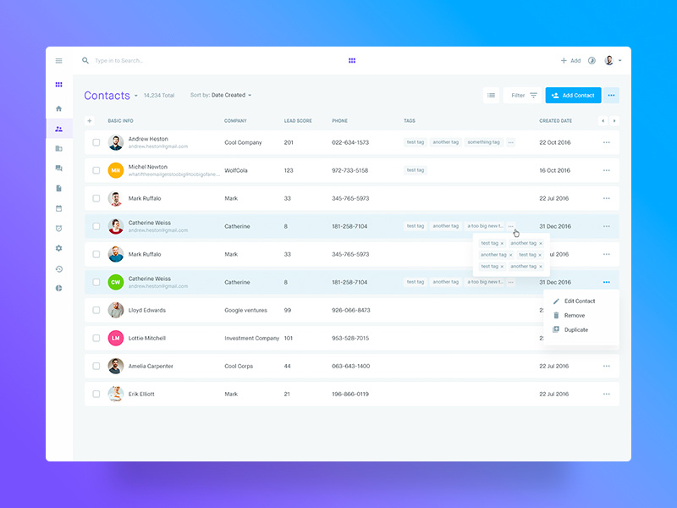

The task is to develop a mock-up React Js application resembling the above design.  
  
Below are the functionalities which are expected to be completed.

1. Write an API in Express JS to list, create, update and delete detail.
2. API data would be viewed in Postman or other REST client tools.
3. Need basic authentication for APIs using middle-ware (Username, Password)
4. State Management, Props will be considered mainly
5. Using Material-UI frameworks will be encouraged
6. Create front-end service in React JS separately
7. Design React Components and Integrate the APIs and show the data in front-end
8. No need to connect to DB, you can create a mock JSON in server side and manipulate it.
9. The fields are Name, Created Date, Number, Incoming Call Count, Location, and Outgoing Call Count.
10. Design JSON effectively to maintain the data like Arrays, Objects and more
11. Add Filter based on Location and search based on Name.
12. Using Material-UI for design is added advantage.

**Note: Please share the source code through GITHUB repository link.**